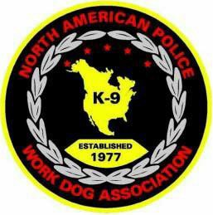
2021 NAPWDA Certification

Oct 18 – 22, 2021 Registration Form

Hosted by: Berkeley County Sheriff Office
PLEASE EMAIL COMPLETED FORM TO Robert.Dwyer@berkeleycountysc.gov

Name: Agency: K-9 Name:
Breed: Age: How Long worked w/this K-9 (years/months):

Is this your first K-9: Yes No
Describe your K9 team (circle one): Single Purpose Dual Purpose Is this K9 team employed by a law enforcement agency? Yes No

Which phases of certification will you be certifying in? (mark below)

Narcotics Detection
Explosive Detection
Tracking/Trailing

Utility Other (please list)

Are you a Current NAPWDA member: Yes No
This year we are holding a NAPWDA certification instead of a “workshop” due to limited time with our Master Trainers and because of COVID restrictions. Certifications will be offered to those teams who MUST CERTIFY THIS YEAR (i.e. department mandated policy) due to the expiration of the one year NAPWDA certification extension that was granted in 2020. You must be a NAPWDA Member to certify. If you are not currently a member visit the NAPWDA website for information on how to become a member.

Waiver:
I hereby waive and relinquish the North American Police Work Dog Association, further referred to as NAPWDA, the Wisconsin State Patrol, Manitowoc Police Department, West Allis Police Department and the University of Wisconsin-Madison Police Department WI. their affiliates, sponsors, organizers, and or all participants, for any injury, mental or physical, to myself or my canine.

I also agree to abide by all rules and regulations as set forth by NAPWDA and the event organizers. I furthermore will accept responsibility for any damage caused by my canine or me to any and all property to include the hotel accommodations and or any training venue.

I furthermore state that my canine and I are in a physical condition necessary to be able to participate in the events, as needed for training and certification purposes.

Date: / /
Sign Name: Print Name:

